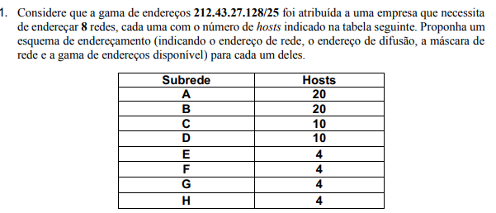

|  |  |  |  |  |
| --- | --- | --- | --- | --- |
|  | **End.Rede** | **End.Difusão** | **Máscara de rede** | **Gama de endereços válidos** |
| **A** | 212.43.27.128 | 212.43.27.159 | /27 | DE 212.43.27.129  ATÉ 212.43.27.158 |
| **B** | 212.43.27.160 | 212.43.27.191 | /27 | DE 212.43.27.161  ATÉ 212.43.27.190 |
| **C** | 212.43.27.192 | 212.43.27.207 | /28 | DE 212.43.27.193  ATÉ 212.43.27.206 |
| **D** | 212.43.27.208 | 212.43.27.223 | /28 | DE 212.43.27.209  ATÉ 212.43.27.222 |
| **E** | 212.43.27.224 | 212.43.27.231 | /29 | DE 212.43.27.225  ATÉ 212.43.27.230 |
| **F** | 212.43.27.232 | 212.43.27.239 | /29 | DE 212.43.27.233  ATÉ 212.43.27.238 |
| **G** | 212.43.27.240 | 212.43.27.247 | /29 | DE 212.43.27.241  ATÉ 212.43.27.246 |
| **H** | 212.43.27.248 | 212.43.27.255 | /29 | DE 212.43.27.249  ATÉ 212.43.27.254 |

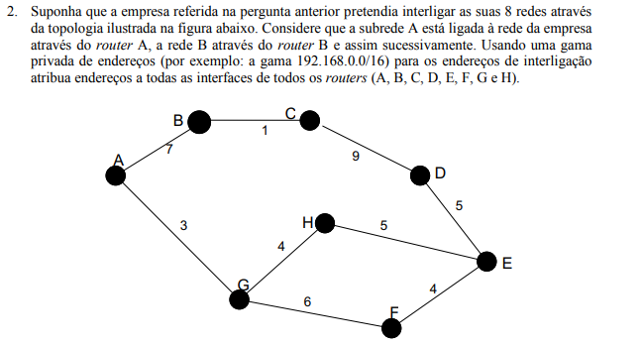

iii

ii

i

ii

i

ii

i

iii

ii

i

ii

i

ii

i

ii

i

ii

i

i

A-

i-192.168.0.1/30

ii-192.168.0.2/30

B-

i-192.168.0.5/30

ii-192.168.0.6/30

C

i-192.168.0.9/30

ii.192.168.0.10/30

D-

i-192.168.0.13/30

ii-192.168.0.14/30

E-

i-192.168.0.17/30

ii-192.168.0.18/30

iii-192.168.0.21/30

F-

i-192.168.0.22/30

ii-192.168.0.25/30

G

i-192.168.0.26/30

ii-192.168.0.29/30

iii-192.168.0.30/30

H

i-192.168.0.33/30

ii-192.168.0.34/30

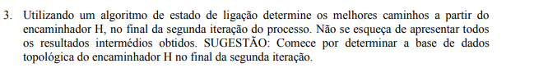

Algoritmo de Dijkstra

Início:

H conhece que pode ir para G e E, diretamente.

1ª iteração:

H conhece os vizinhos de G(A,F) e de E(D,F).

2ªiteração:

H conhece os vizinhos de D(C) e A(B).

LSA-Passo 0:

|  |  |  |  |  |  |  |  |  |
| --- | --- | --- | --- | --- | --- | --- | --- | --- |
| Passo | N | D(A),P(A) | D(B),P(B) | D(C),P(C) | D(D),P(D) | D(E),P(E) | D(F),P(F) | D(G),P(G) |
| 0 | H | ∞ | ∞ | ∞ | ∞ | 5,H | ∞ | 4,H |

[FIM DA ITERAÇÃO INÍCIO]

LSA-Passo 1:

|  |  |  |  |  |  |  |  |  |
| --- | --- | --- | --- | --- | --- | --- | --- | --- |
| Passo | N | D(A),P(A) | D(B),P(B) | D(C),P(C) | D(D),P(D) | D(E),P(E) | D(F),P(F) | D(G),P(G) |
| 0 | H | ∞ | ∞ | ∞ | ∞ | 5,H | ∞ | 4,H |
| 1 | HG | 7,G | ∞ | ∞ | ∞ | 5,H | 10,G | ---- |

LSA-Passo 2:

|  |  |  |  |  |  |  |  |  |
| --- | --- | --- | --- | --- | --- | --- | --- | --- |
| Passo | N | D(A),P(A) | D(B),P(B) | D(C),P(C) | D(D),P(D) | D(E),P(E) | D(F),P(F) | D(G),P(G) |
| 0 | H | ∞ | ∞ | ∞ | ∞ | 5,H | ∞ | 4,H |
| 1 | HG | 7,G | ∞ | ∞ | ∞ | 5,H | 10,G | ---- |
| 2 | HGE | 7,G | ∞ | ∞ | 10,E | ---- | 9,E |  |

[FIM DA ITERAÇÃO 1]

LSA-Passo 3:

|  |  |  |  |  |  |  |  |  |
| --- | --- | --- | --- | --- | --- | --- | --- | --- |
| Passo | N | D(A),P(A) | D(B),P(B) | D(C),P(C) | D(D),P(D) | D(E),P(E) | D(F),P(F) | D(G),P(G) |
| 0 | H | ∞ | ∞ | ∞ | ∞ | 5,H | ∞ | 4,H |
| 1 | HG | 7,G | ∞ | ∞ | ∞ | 5,H | 10,G | ---- |
| 2 | HGE | 7,G | ∞ | ∞ | 10,E | ---- | 9,E | --- |
| 3 | HGEA | --- | 14,A | ∞ | 10,E | ---- | 9,E | --- |

LSA-Passo 4:

|  |  |  |  |  |  |  |  |  |
| --- | --- | --- | --- | --- | --- | --- | --- | --- |
| Passo | N | D(A),P(A) | D(B),P(B) | D(C),P(C) | D(D),P(D) | D(E),P(E) | D(F),P(F) | D(G),P(G) |
| 0 | H | ∞ | ∞ | ∞ | ∞ | 5,H | ∞ | 4,H |
| 1 | HG | 7,G | ∞ | ∞ | ∞ | 5,H | 10,G | ---- |
| 2 | HGE | 7,G | ∞ | ∞ | 10,E | ---- | 9,E | --- |
| 3 | HGEA | --- | 14,A | ∞ | 10,E | ---- | 9,E | --- |
| 4 | HGEAF | --- | 14,A | ∞ | 10,E | ---- | ----- |  |

LSA-Passo5:

|  |  |  |  |  |  |  |  |  |
| --- | --- | --- | --- | --- | --- | --- | --- | --- |
| Passo | N | D(A),P(A) | D(B),P(B) | D(C),P(C) | D(D),P(D) | D(E),P(E) | D(F),P(F) | D(G),P(G) |
| 0 | H | ∞ | ∞ | ∞ | ∞ | 5,H | ∞ | 4,H |
| 1 | HG | 7,G | ∞ | ∞ | ∞ | 5,H | 10,G | ---- |
| 2 | HGE | 7,G | ∞ | ∞ | 10,E | ---- | 9,E | --- |
| 3 | HGEA | --- | 14,A | ∞ | 10,E | ---- | 9,E | --- |
| 4 | HGEAF | --- | 14,A | ∞ | 10,E | ---- | ----- | ---- |
| 5 | HGEAFD | --- | 14,A | 19,D | ---- | ---- | ----- | ---- |

[FIM DA ITERAÇÃO 2]

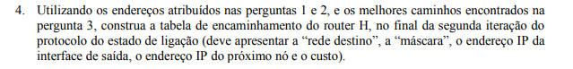

|  |  |  |  |  |
| --- | --- | --- | --- | --- |
| Rede Destino | Máscara | End.IP inter.saída | End. IP prox. Nó | custo |
| 212.43.27.128(A) | /27 | ii-192.168.0.34/30 | 192.168.0.30/30(G-iii) | 7 |
| 212.43.27.160(B) | /27 | ii-192.168.0.34/30 | 192.168.0.30/30(G-iii) | 14 |
| 212.43.27.192(C) | /28 | i-192.168.33/30 | 192.168.0.21/30(E-iii) | 19 |
| 212.43.27.208(D) | /28 | i-192.168.33/30 | 192.168.0.21/30(E-iii) | 10 |
| 212.43.27.224(E) | /29 | i-192.168.33/30 | 192.168.0.21/30(E-iii) | 5 |
| 212.43.27.232(F) | /29 | i-192.168.0.33/30 | 192.168.0.21/30(E-iii) | 9 |
| 212.43.27.240(G) | /29 | i-192.168.0.34/30 | 192.168.0.30/30(G-iii) | 4 |
| 212.43.27.248(H) | /29 | ------ | -------- | 0 |

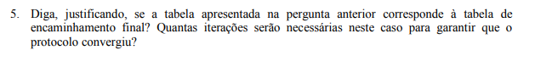

Não, uma vez que existem redes para as quais o router H ainda não sabe que existem caminhos com menos custos para chegar a elas.()

Seriam necessárias 3 iterações(sem ser do dijkstra), para garantir que o protocolo convergiu.

Caso se fizessem as 3 iterações:

Iteração 3:

H conhece os vizinhos de C(B) e B(C)

LSA-Passo 6

|  |  |  |  |  |  |  |  |  |
| --- | --- | --- | --- | --- | --- | --- | --- | --- |
| Passo | N | D(A),P(A) | D(B),P(B) | D(C),P(C) | D(D),P(D) | D(E),P(E) | D(F),P(F) | D(G),P(G) |
| 0 | H | ∞ | ∞ | ∞ | ∞ | 5,H | ∞ | 4,H |
| 1 | HG | 7,G | ∞ | ∞ | ∞ | 5,H | 10,G | ---- |
| 2 | HGE | 7,G | ∞ | ∞ | 10,E | ---- | 9,E | --- |
| 3 | HGEA | --- | 14,A | ∞ | 10,E | ---- | 9,E | --- |
| 4 | HGEAF | --- | 14,A | ∞ | 10,E | ---- | ----- | ---- |
| 5 | HGEAFD | --- | 14,A | 19,D | ---- | ---- | ----- | ---- |
| 6 | HGEAFDB | ---- | ---- | 15,B | ---- | ---- | ---- | ---- |

LSA-Passo7

|  |  |  |  |  |  |  |  |  |
| --- | --- | --- | --- | --- | --- | --- | --- | --- |
| Passo | N | D(A),P(A) | D(B),P(B) | D(C),P(C) | D(D),P(D) | D(E),P(E) | D(F),P(F) | D(G),P(G) |
| 0 | H | ∞ | ∞ | ∞ | ∞ | 5,H | ∞ | 4,H |
| 1 | HG | 7,G | ∞ | ∞ | ∞ | 5,H | 10,G | ---- |
| 2 | HGE | 7,G | ∞ | ∞ | 10,E | ---- | 9,E | --- |
| 3 | HGEA | --- | 14,A | ∞ | 10,E | ---- | 9,E | --- |
| 4 | HGEAF | --- | 14,A | ∞ | 10,E | ---- | ----- | ---- |
| 5 | HGEAFD | --- | 14,A | 19,D | ---- | ---- | ----- | ---- |
| 6 | HGEAFDB | ---- | ---- | 15,B | ---- | ---- | ---- | ---- |
| 7 | HGEAFDBC | ---- | ---- | ----- | ---- | ---- | ---- | ---- |

[FIM ITERAÇÃO 3]

Só após 3 iterações conhece este caminho